St. Luke’s Church,
Cannock
26th – 28th November 2026
Christmas Tree Festival

Have a tree to promote your charity,
business, school, organisation or in memory of someone special
admission free

Thursday 10am -6pm Friday 10am -4pm Saturday 10am -5pm

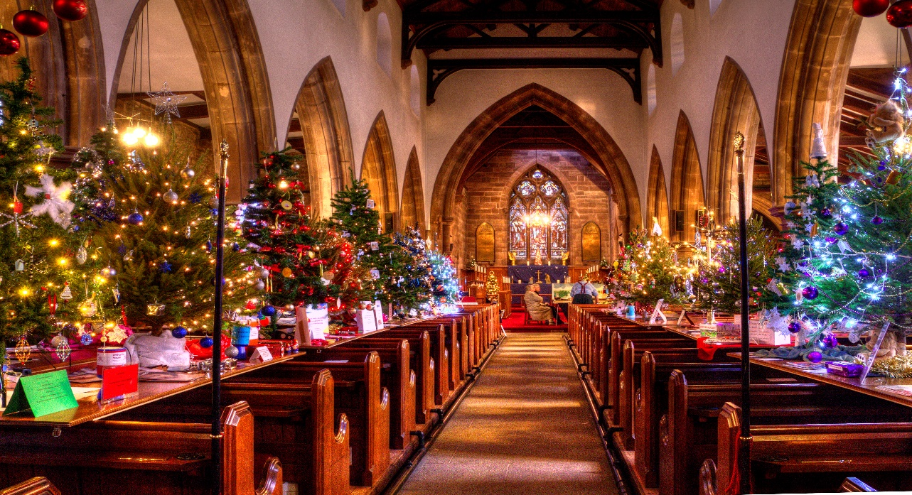

Thursday 28th November until Saturday 30th November 2024

Thursday 28th November until Saturday 30th November 2024

Conditions of Entry

Tree entry is free. Trees must be artificial (4—5ft) and must be lit.

Decorate your tree and container however you wish but please note, no candles, naked lights, musical effects or edible
decorations allowed.

Electricity will be supplied by each tree so please use plug in lights. Please light your tree as brightly as possible (but not flashing) One set of lights per tree.

The organisers reserve the right to exclude any tree that is unsafe or offensive.
You may put a collection box and promotional materials by your tree (your responsibility)

Entry forms in by MONDAY of week before 16.11.26

Set Up times:

Tuesday 4pm—7pm

Wednesday 1pm—4pm

Take Down:

Sunday 11am – 4pm

Monday 10am—11am

St Luke’s Church Cannock 26th – 28th November 2025
Christmas Tree Festival
Entry Form

Contact …………………………………………………………………………..

Organisation …………………………………………………………………..

Address ………………………………………………………………………….

……………………………………………………………………………………….

Email ……………………………………………………………………………..

Telephone Number ………………………………………………………..

Attend to assemble (please tick)

Tuesday 4pm—7pm …………………………………...

Wednesday 1pm—4pm …………………...

Take Down

Sunday 11am—4pm ………………………………

Monday 10am—11am …………………………..

Entry Forms to—Parish Office, Church Street Cannock WS11 1DE

Enquiries—Tina Ward
01543 571482/ 07811 698608twoward@btinternet.com
Anne Higgs 01543 579246/ 07837 846413 annehiggs1@gmail.com

Friday 7.30pm

An evening of music and
readings with St Luke’s choir

Tickets £5 from office or wardens or £5 on door.

Light refreshments, and mulled wine available


This Photo by Unknown Author is licensed under CC BY

